Introduction

As we know, global macroeconomic environment is one of essential factors to the change of both equity market and commodity market. And because of that, we can assume there are some correlation between these two markets, which is especially obvious under unsettled market period.

For example, the correlation coefficient between BCOM index and SPX index is up to 0.659766 in Nov 2008.

However this kind of high correlation coefficient is not common. Before 2008, the correlation between BCOM index and SPX index stay at a very low level for most of years and even close to zero, like in 2001 the correlation coefficient is only -0.0023. And what we are going to do is to find the correlation between equity and different commodities in different periods and try to analysis reasons behind these phenomenon.

2008 11月期货与股票的return，看起来是股票引导着期货价格

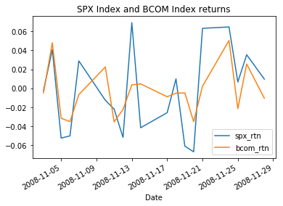

correlation coefficient between BCOM Index and SPX Index







2017.11-2016.10





2016.9-2015.7





2015.6-2014.4





2014.3-2013.3





2013.2-2012.1





2011.12-2010.10





2010.9-2009.8





2009.7-2008.6





2008.7-2007.3





2007.2-2006.1



